Phase 2 pCT Scanner Coordinate Systems

# Overview

Two coordinate systems and the relation between them are defined for pCT (Fig. 1). First is the reconstruction coordinate system. This system is fixed relative to the imaging subject. For a head scan with the object in a standard supine, head first position (lying on the back, head into the scanner), the axes of the reconstruction coordinate system are defined with respect to anatomical directions following the DICOM standard described in PS 3.3 – 2011 [1]. Note that this does not conflict with placing the imaging subject differently than the standard position, e.g. prone. The second system is the detector coordinate system. In a typical tomographic scanner, this system rotates around the reconstruction system in a clockwise direction from 0 degree to 360 degree, from the perspective of an observer on the floor, but does not translate relative to it. This means that origin of both systems coincide.

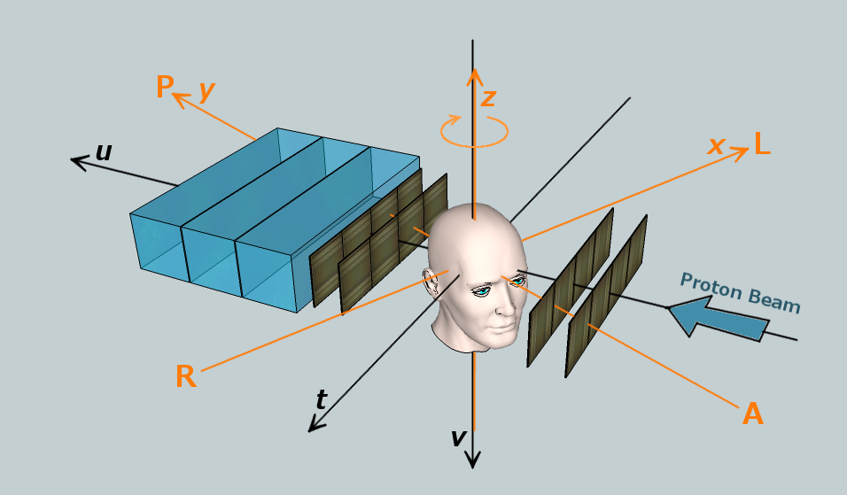

**Fig. 1.** Phase 2 scanner coordinate systems. The orange coordinate axes correspond to the reconstruction coordinate system and the black axes to the detector coordinate system. In the Phase 2 scanner, the imaged object (phantom) rotates as shown by the orange arrow, i.e. in clockwise direction when viewed from above.

# Reconstruction system (*x, y, z*)

For a nominal patient scan, a patient orientation of "supine" and "head-first" is assumed. In this orientation, the *x*-axis is the R-L anatomical axis, the *y*-axis is the A-P anatomical axis, and the *z*-axis is the I-S anatomical axis. The origin of this system is the center of the reconstruction volume, which is defined more rigorously by the intersection of the rotational axis of the rotation stage (perpendicular to *u* and *t*) and the orthogonal plane that intersects the center of the detectors (in *v*). The typical rendering of the reconstructed images should be viewed from negative towards positive *z*, with the *x*-axis horizontal and the *y*-axis vertical. In the DICOM convention, the positive *x*-axis points towards the anatomical left of the patient, and the positive *y*-axis points to the anatomical posterior direction. This is a right-handed coordinate system.

# Detector system (*t, u, v*)

This system is defined by the proton beam axis and the pCT detectors. The origin of this system shares the point in space with the origin of the reconstruction system. The positive *t*-axis points towards the left of the observer when looking in proton beam direction, the positive *u*-axis points in beam direction, and the positive *v*-axis is defined by the fact that *t*, *u*, *v* is a right-handed coordinate system. The rotation of the detector system relative to the reconstruction system is around the *z*-axis and follows the right-hand-rule, i.e., the detectors rotate counterclockwise when the observer is looking towards the negative z-axis. If the detector system is fixed, as is the case for the Phase 2 scanner, the phantom rotates clockwise around the detector *v*-axis when looking towards the positive *v*-axis, thus likewise following the right-hand rule. At 0 degrees, the *u*-axis (beam axis) points in the direction of the positive *y*-axis, and the *t*-axis points in the direction of the negative *x*-axis. In other words, when a head is scanned in standard orientation (supine, head first) it will be facing the beam.

# Phase 2 scanner orientation

The Phase 2 scanner will be mounted such that the head phantom is upright (the superior (z-) axis points towards the ceiling) and the rotational stage axis is vertical. For the 0-degree position of the rotational stage, the phantom will be facing the front detector module and the beam, and the top of the head will point to the ceiling. The head will then rotate clockwise when viewed down from the ceiling (in negative *z*-axis direction). The same scan in the future gantry-mounted scanner (Phase 3) will have the patient lying on their back (supine) with the head going into the gantry (head-first). At gantry rotation of 0 degrees, the beam delivery system (nozzle) will be at its highest position and the beam axis will point down in posterior direction of the patient. The gantry will then rotate clockwise when the observer is facing it. From the point of view of image reconstruction, the Phase 2 and 3 arrangements will be identical and conform to DICOM standard.

# References

1. Digital Imaging and Communications in Medicine (DICOM). <http://medical.nema.org/standard.html>